

Project Report

Wireless Networking Fundamentals

Department of ECE

PES University

Faculty In charge: PROF. M Rajasekar

Submitted by:

Vishal Singh S - PES1UG19EC351

Sem: VI Semester

TITLE:

Water Level Detection on Smartphone via Bluetooth Connection

Introduction:

Water level sensors are used to measure the level of water in various application such as tanks, wells and rivers. With the increasing use of smartphone ,it has become possible to integrate water level sensor with smartphone via Bluetooth connection

By connecting a water level sensor to a smartphone, the user can easily monitor the water level remotely without need to physically visit the location of sensor. The user can also set alert to notify them when the water level reaches a certain level, which can be useful for monitoring water usage or preventing floods.

Block Diagram:

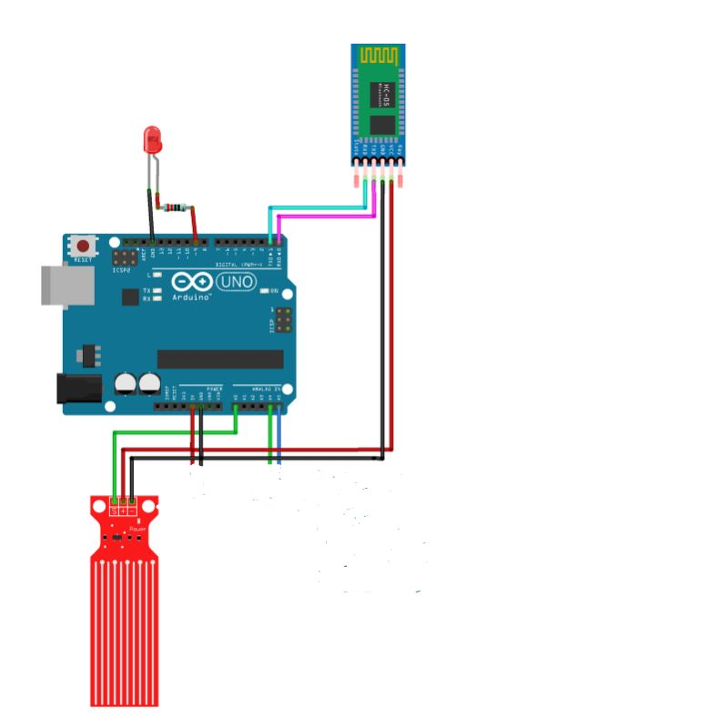

Connections: In water level sensor the Signal S is connected to A0 of aurdino uno and + and – are connected to Vcc and Gnd of HC-05 bluetooth module respectively. Connect the anode(positive leg) of led to the pin 8 of aurdino uno and cathode

(negative leg) of led to one end of a resistor(270 ohm) and other end of resistor to gnd pin of aurdino.

Install Bluetooth serial monitor app from your smartphone and connect HC-05 bluetooth module in the app and you will be able to see the water level in Bluetooth serial monitor

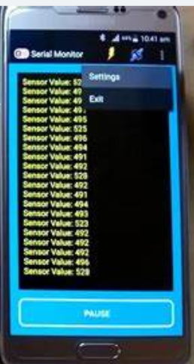\

Working:

The water level sensor senses the water level ,with the help of hc-05 bluetooth module Bluetooth serial monitor gets connected and display the water level sensed by sensor. If the water level reaches beyond a threshold value led light is glown.

Code in aurdino :

int waterLevelSensor = A0;

int led1 = 8;

void setup() {

  Serial.begin(9600);

  pinMode(led1, OUTPUT);

}

void loop() {

  int waterLevel = analogRead(waterLevelSensor);

  Serial.println(waterLevel);

if (Serial.available()) {

String command = Serial.readStringUntil('\n');

if (waterLevel >500) {

digitalWrite(led1, HIGH);}

else {

digitalWrite(led1, LOW);}

}

}

Result:

The Bluetooth serial monitor app in the smartphone is able to display water level which is sensed by water sensor.